EXERCISE 1 — User Upcoming Events
Question
Show all upcoming events a user registered for in their own city.
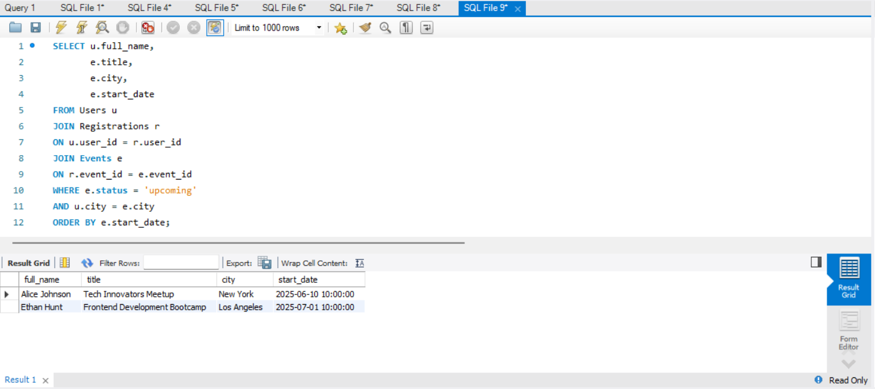
EXERCISE 2 — Top Rated Events
Question
Find events with highest average rating.
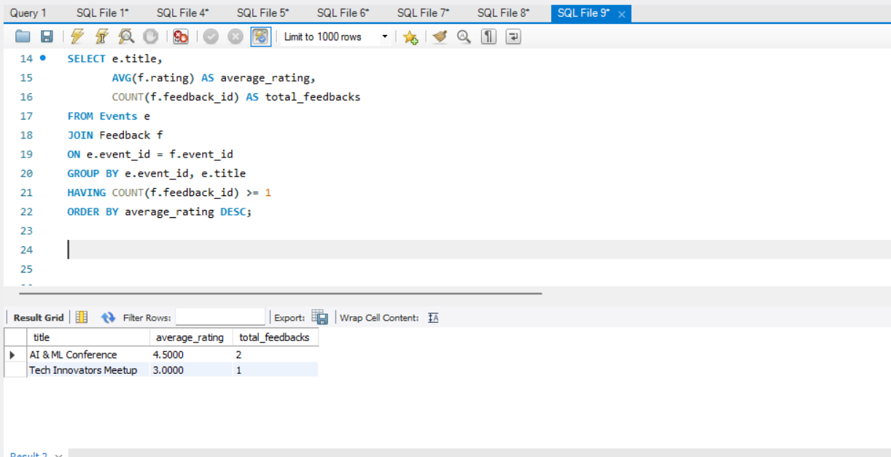

EXERCISE 3 — Inactive Users
Question
Users who did not register in last 90 days.
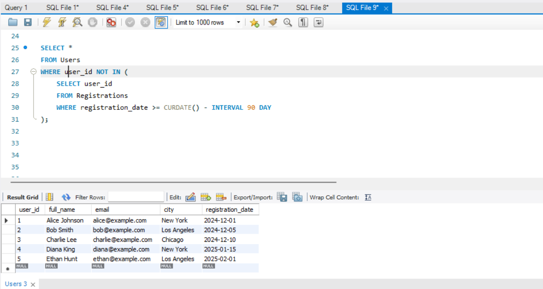
EXERCISE 4 — Peak Session Hours
Question
Count sessions between 10 AM and 12 PM.
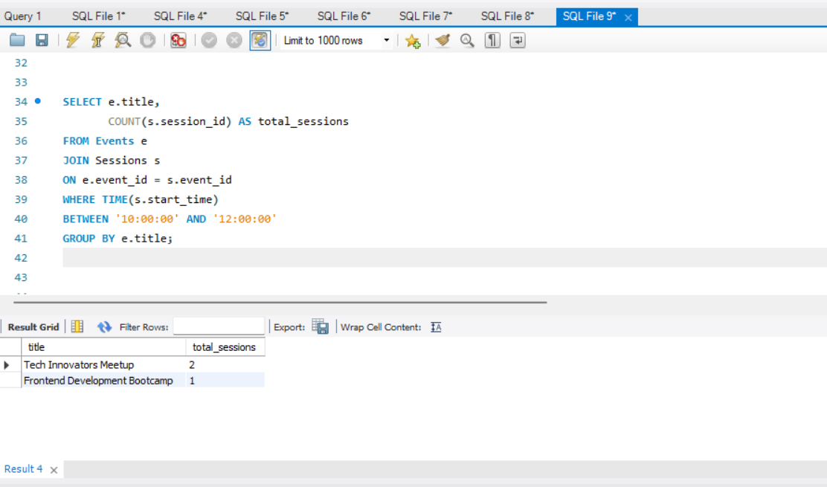

EXERCISE 5 — Most Active Cities
Question
Show top 5 cities with highest registrations.
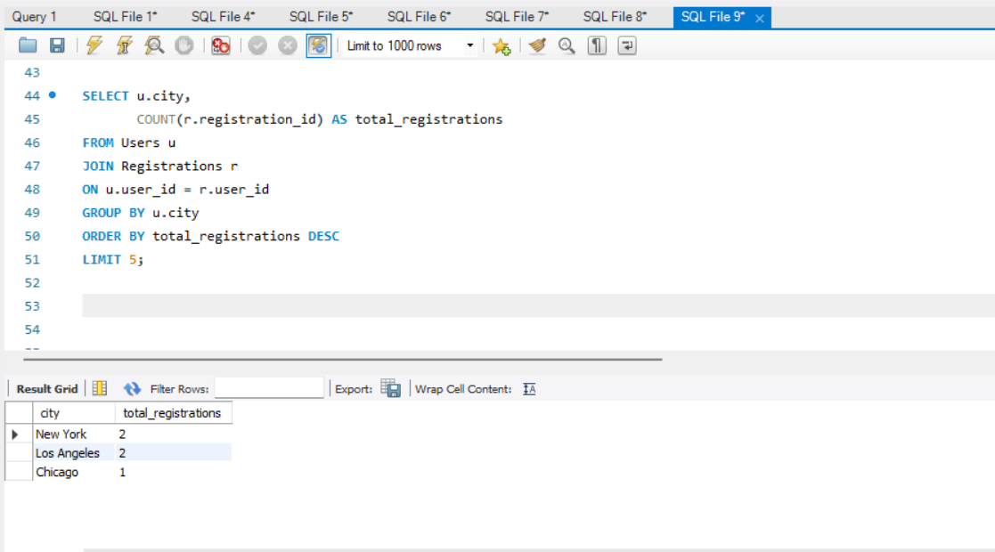
EXERCISE 6 — Event Resource Summary
Question
Count PDFs, images, and links for each event.
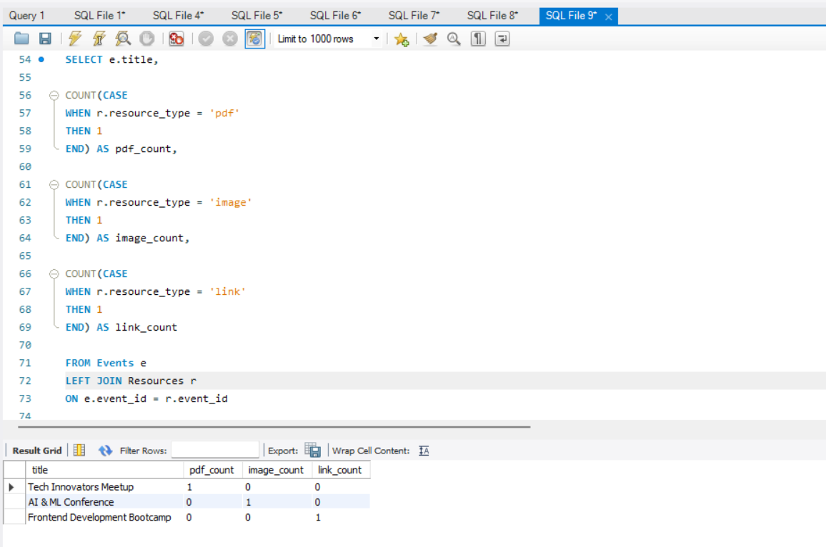
EXERCISE 7 — Low Feedback Alerts
Question
Users who gave rating below 3.
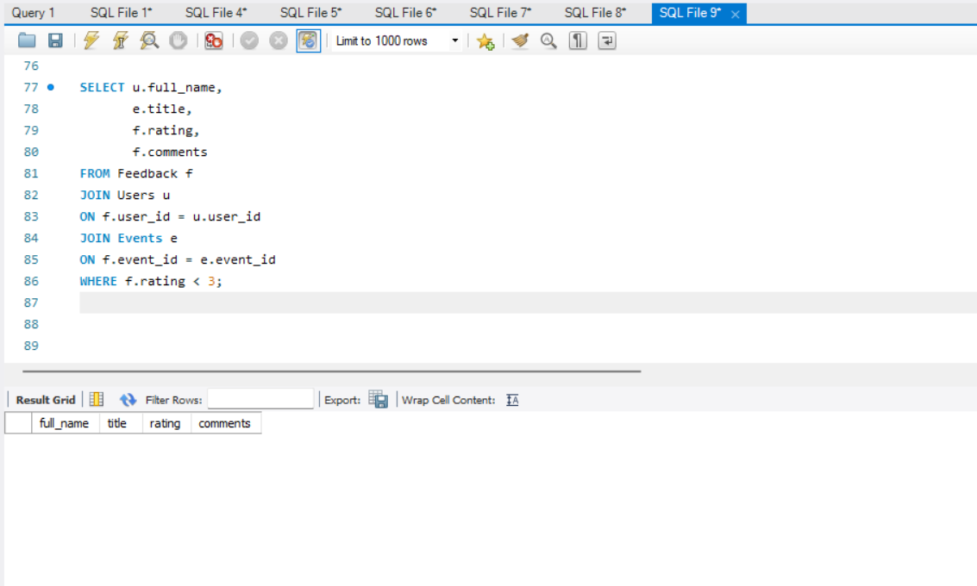
EXERCISE 8 — Sessions per Upcoming Event
Question
Show upcoming events with session count.
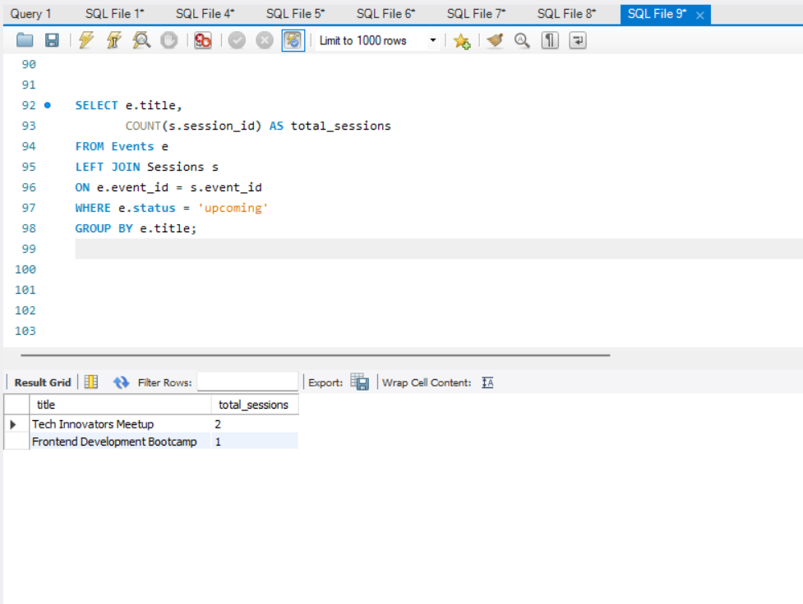
EXERCISE 9 — Organizer Event Summary
Question
Show organizer-wise event count and status.
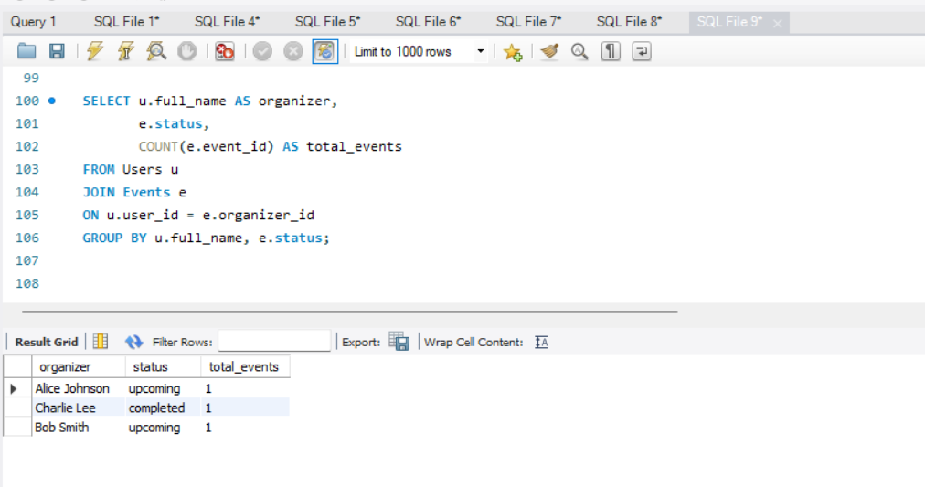
EXERCISE 10 — Feedback Gap
Question
Find events with registrations but no feedback.
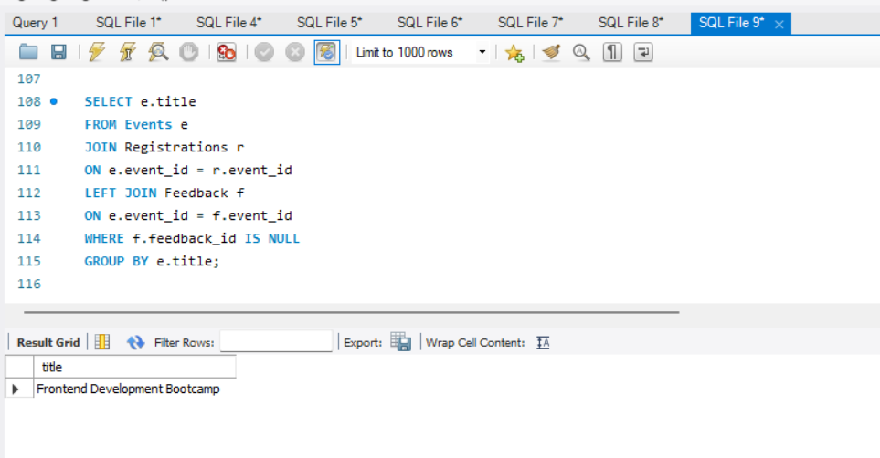

EXERCISE 11 — Daily New User Count
Question
Find number of users registered each day in last 7 days.
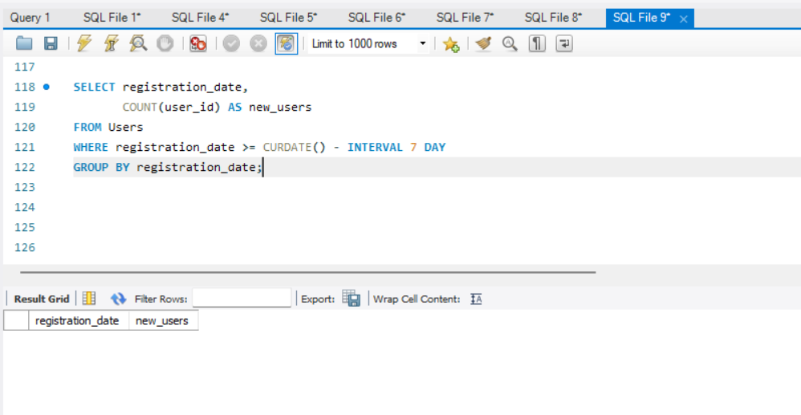
EXERCISE 12 — Event with Maximum Sessions
Question
Find event having highest number of sessions.
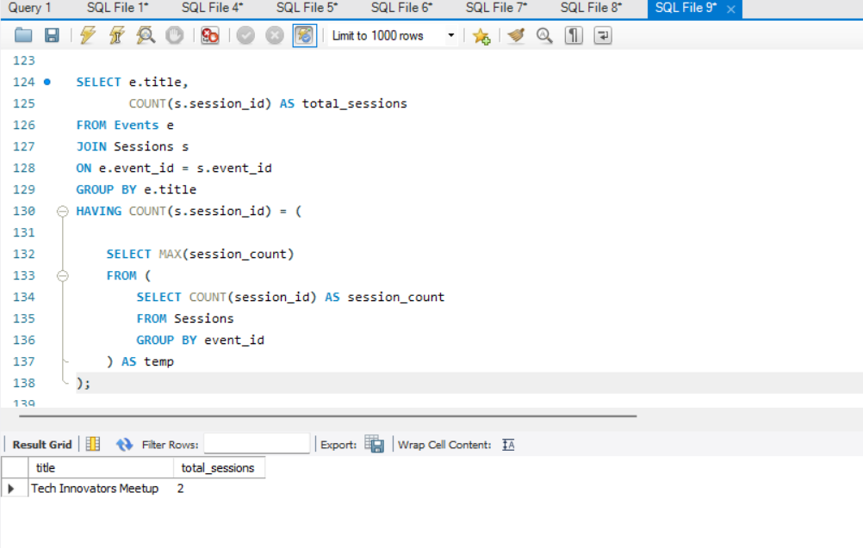

EXERCISE 13 — Average Rating per City
Question
Find average feedback rating city-wise.
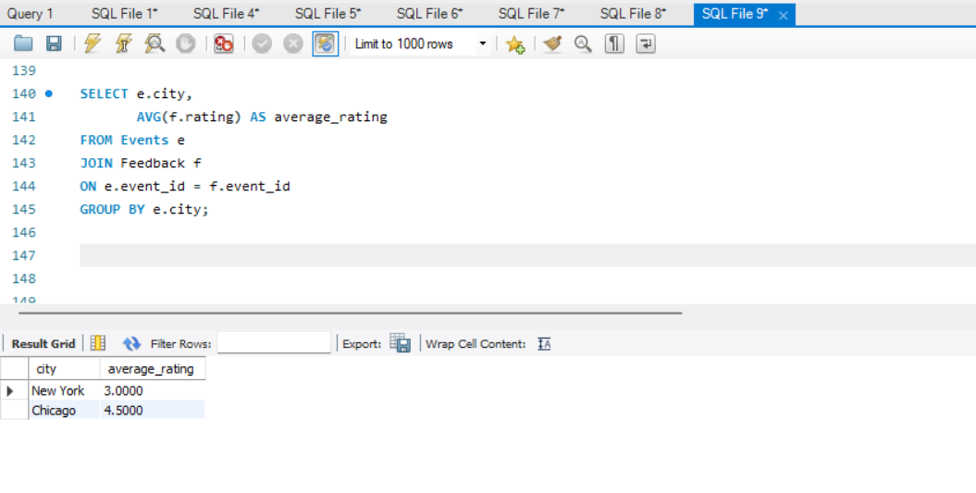
EXERCISE 14 — Most Registered Events
Question
Find top 3 events with highest registrations.
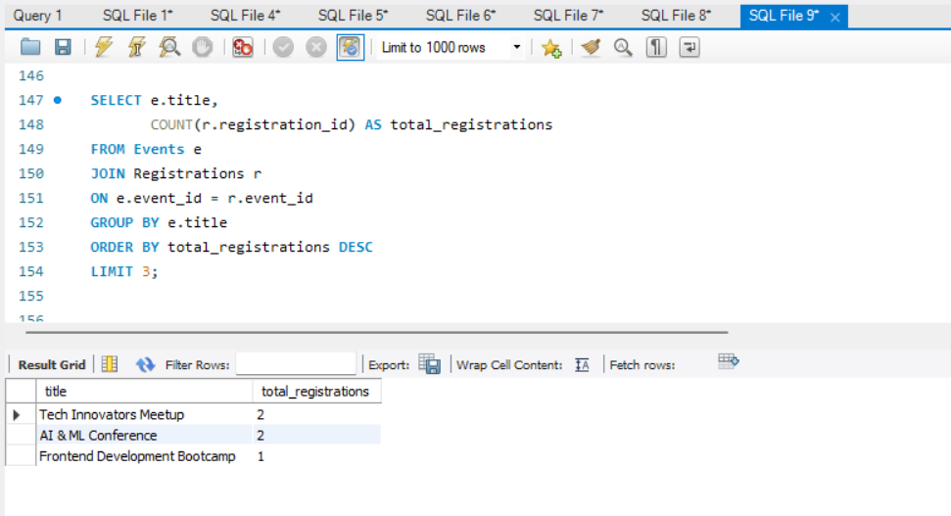

EXERCISE 15 — Event Session Time Conflict
Question
Find overlapping sessions inside same event.
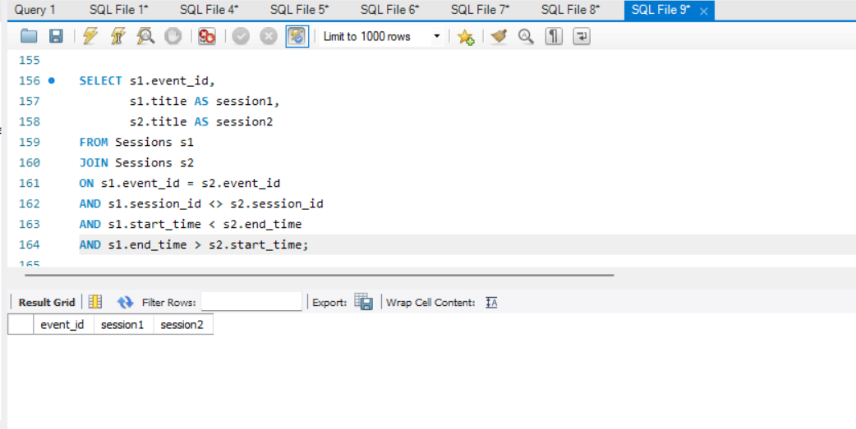
EXERCISE 16 — Unregistered Active Users
Question
Find users created in last 30 days but not registered for any event
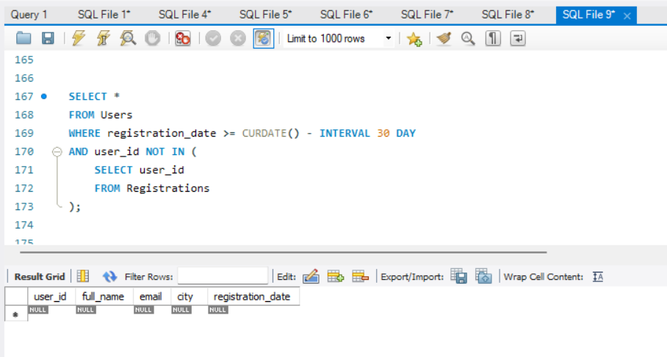

EXERCISE 17 — Multi-Session Speakers
Question
Find speakers handling more than one session.
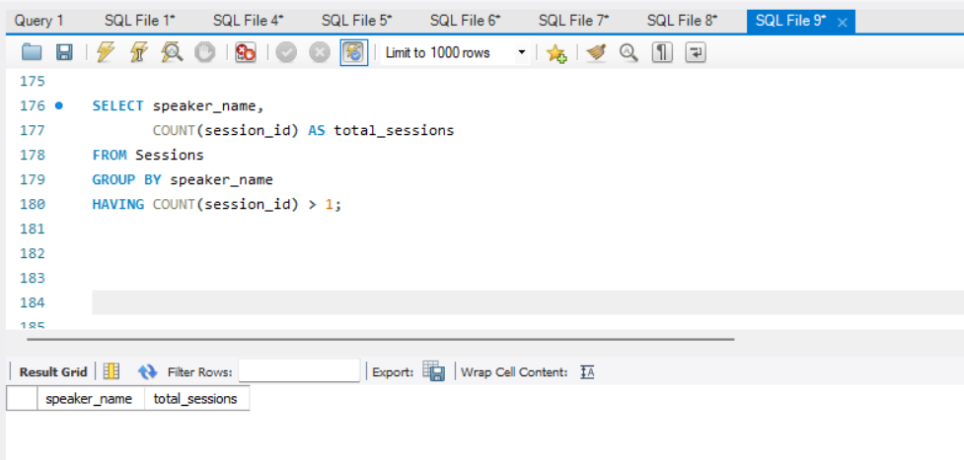
EXERCISE 18 — Resource Availability Check
Question
Find events with NO resources uploaded.
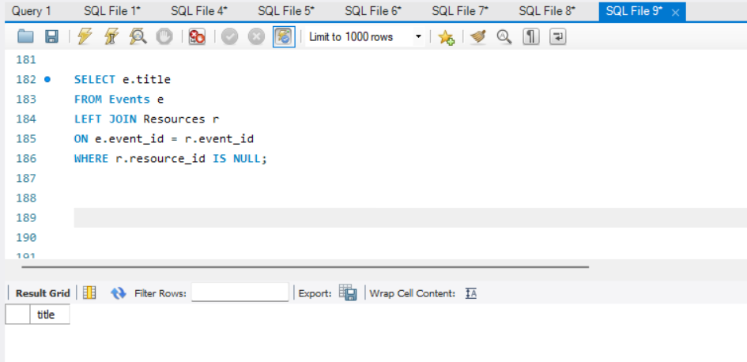

EXERCISE 19 — Completed Events with Feedback Summary
Question
Show completed events with registrations and average feedback.

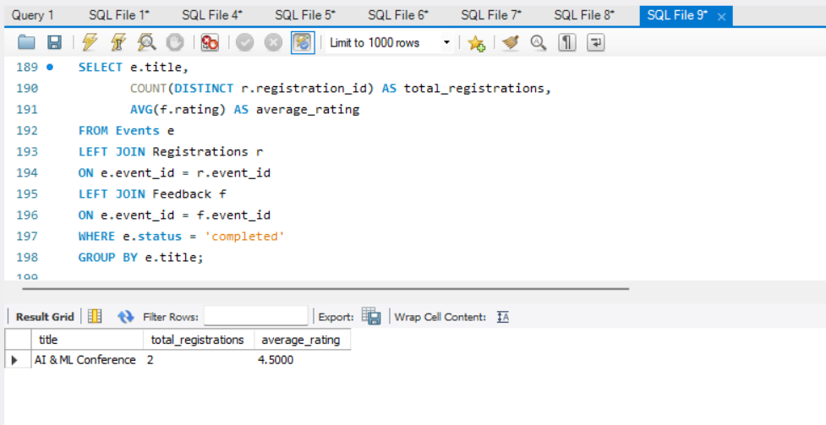

EXERCISE 20 — User Engagement Index
Question
Count:
- events attended
- feedback submitted
for each user.
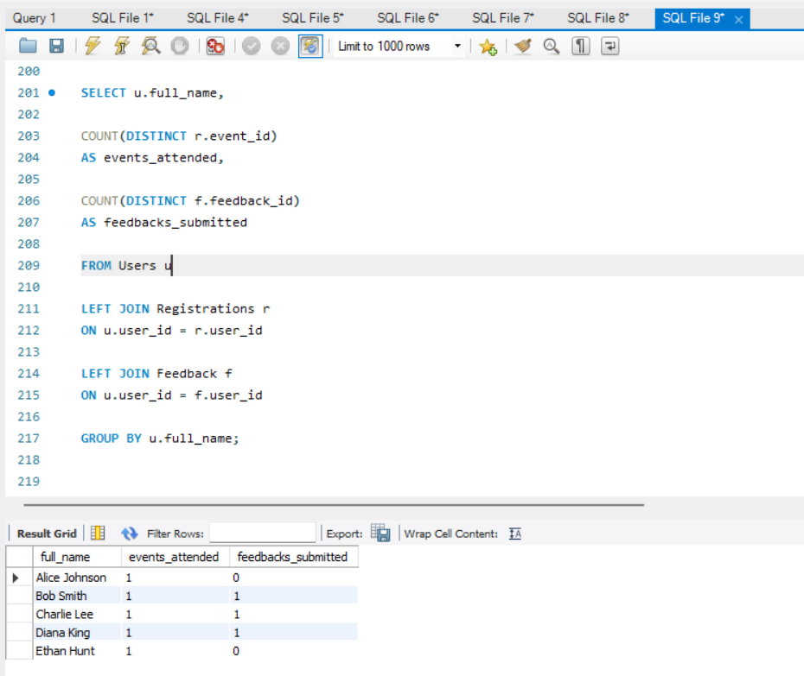

EXERCISE 21 — Top Feedback Providers
Question
Find top 5 users who submitted most feedbacks.
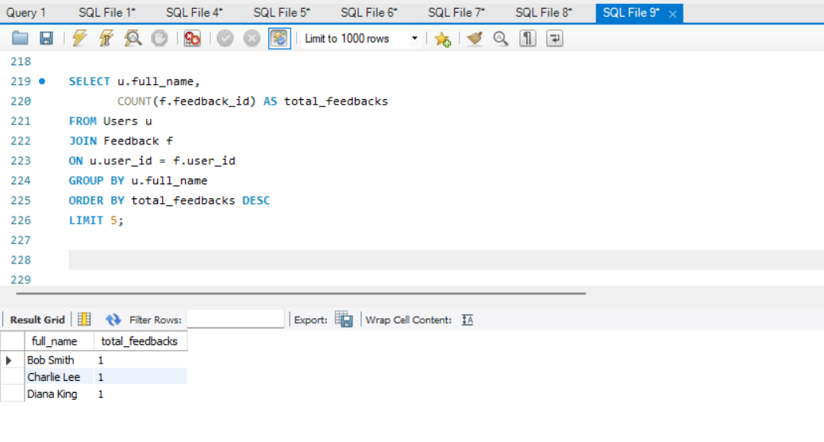
EXERCISE 22 — Duplicate Registrations Check
Question
Find users registered more than once for same event.
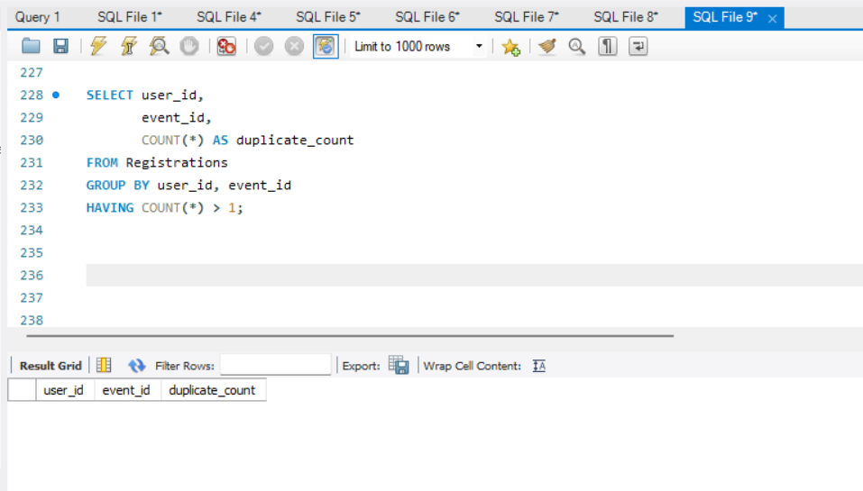

EXERCISE 23 — Registration Trends
Question
Show month-wise registration count for past 12 months.
EXERCISE 24 — Average Session Duration per Event
Question
Find average session duration in minutes.
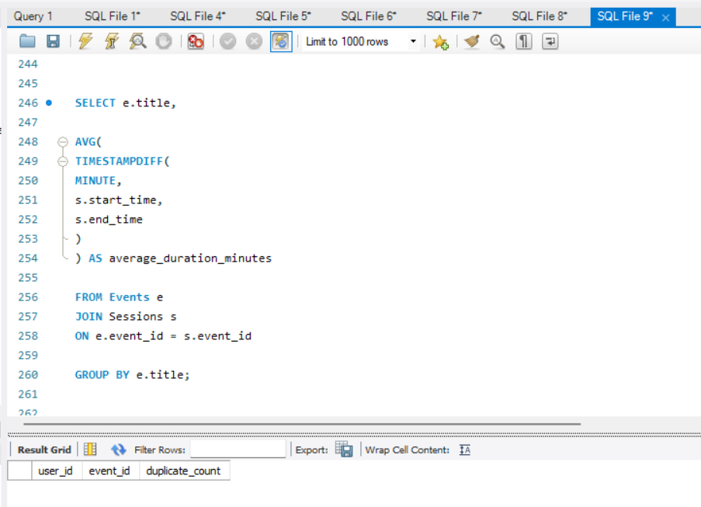

EXERCISE 24 — Average Session Duration per Event
Question
Find average session duration in minutes.
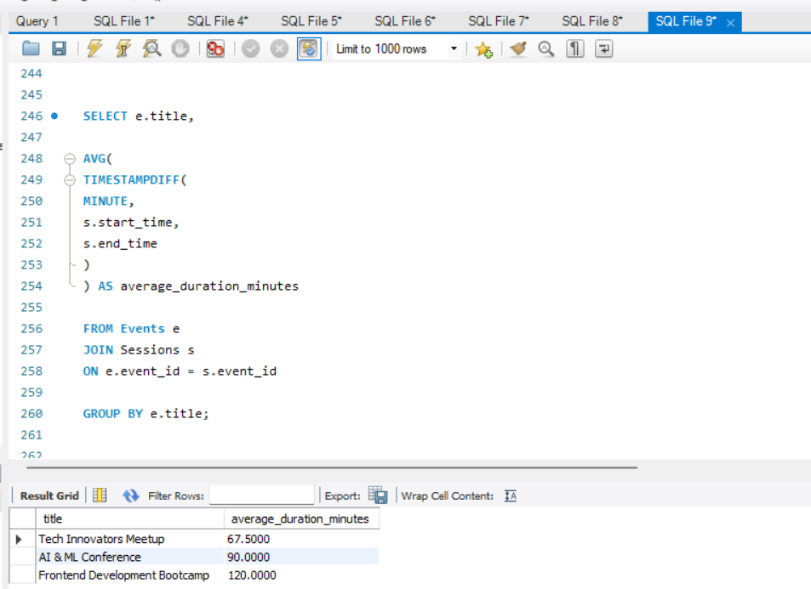
EXERCISE 25 — Events Without Sessions
Question
Find events having no sessions.
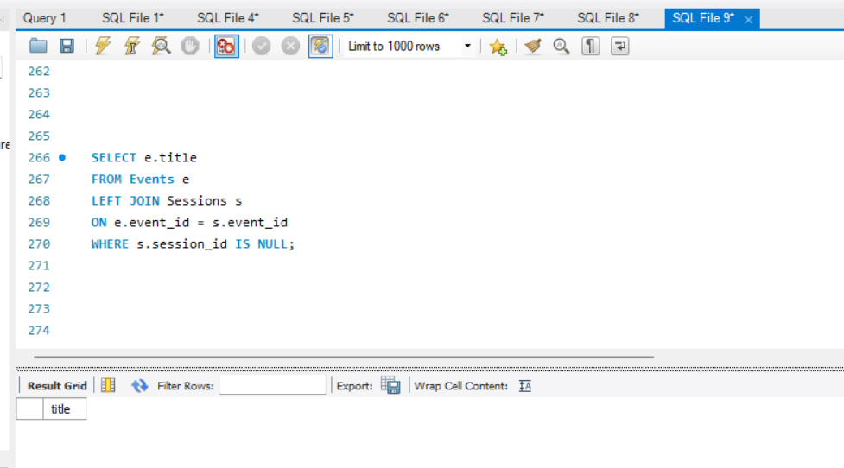

S